Deployment Steps

1. Create Apex Class – EmailPublisherForCase
2. Go To Setup -> [Search Support Settings] -> Support Settings -> Edit and Configure Class name as below.  
     
   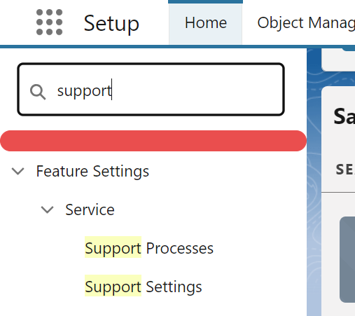  
   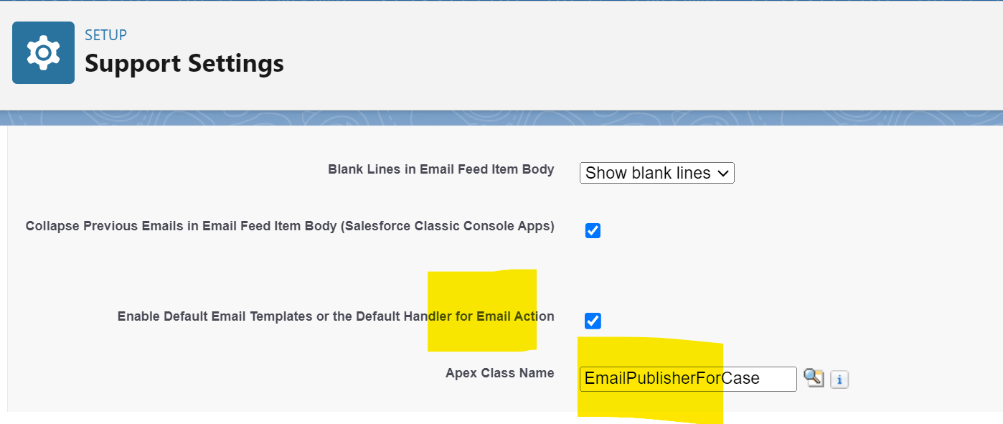
3. Go to Object Manager -> Case Object -> Button Links & Actions
   1. Access Email Button  
      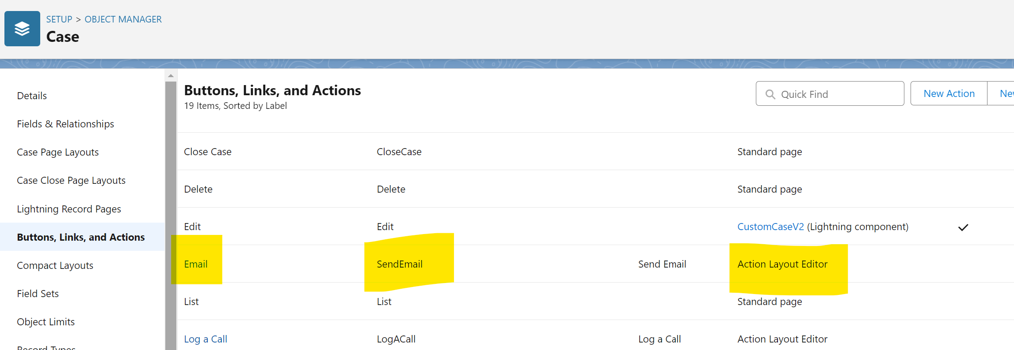
   2. Edit Layout  
      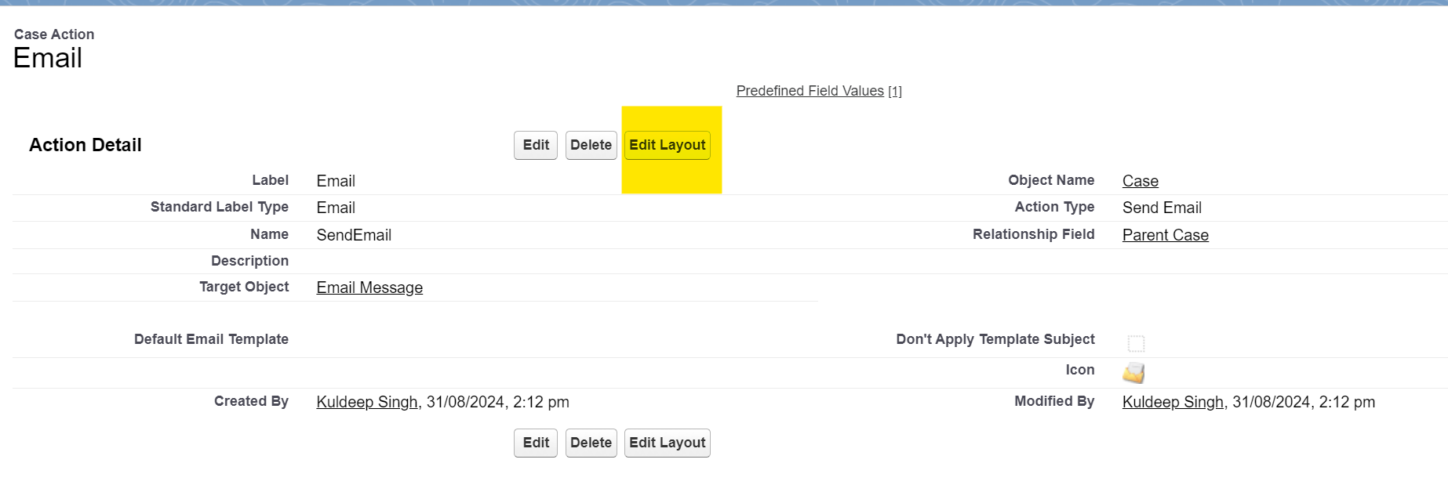
   3. Remove From and add From Address and make it READ ONLY   
      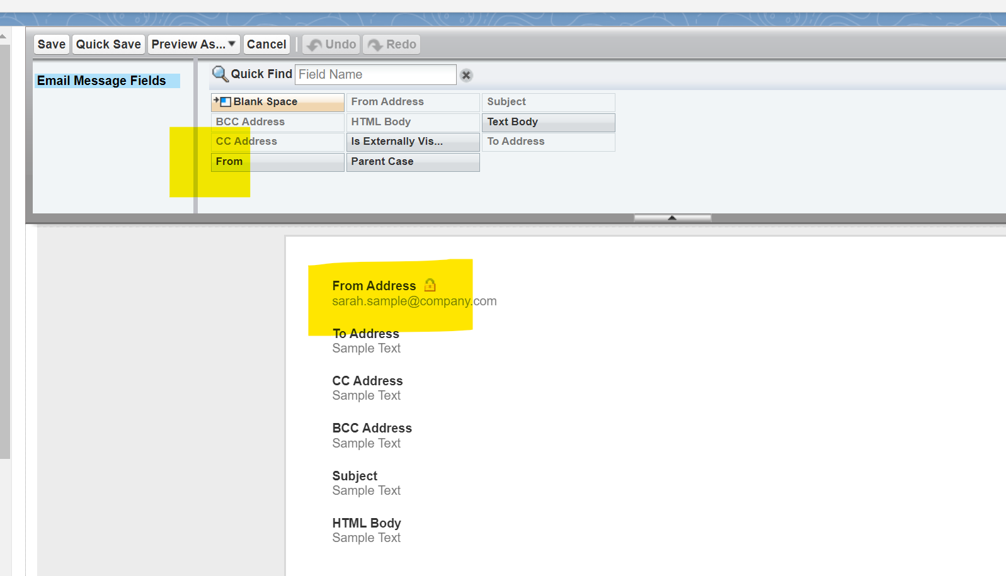
4. Add Test Class and Done.
5. Create Custom Label  
     
   